Major General Ryan M. Janovic
Commanding General, U.S. Army Cyber Center of Excellence and Fort Eisenhower
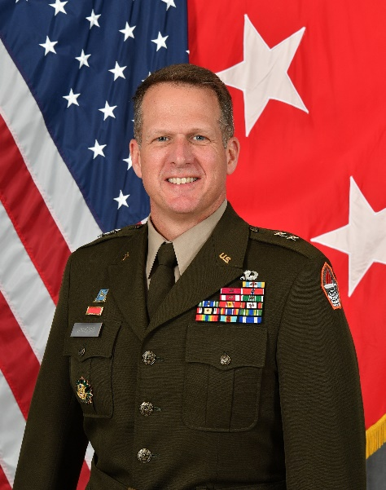
Major General Ryan M. Janovic is the 42nd Commanding General, U.S. Army Cyber Center of Excellence and Fort Eisenhower.
A native of Akron, Ohio, Ryan graduated from the U.S. Military Academy at West Point in 1993 and commissioned into the Military Intelligence Corps. He began his career as a platoon leader in the 201st Military Intelligence Battalion, 513th Military Intelligence Brigade at (then) Fort Gordon, Georgia.
As a junior captain, he served as the brigade intelligence officer for the 1st Brigade, 2nd Infantry Division in the Republic of Korea. He remained overseas with the 25th Infantry Division (Light).
Following Command and General Staff College, MG Janovic served in Baghdad, Iraq as an aide-de-camp and deputy executive officer within the headquarters of Multi-National Forces - Iraq. In the summer of 2005, he served as both a battalion and brigade operations officer with the 902d Military Intelligence Group, the Army’s premier multi-discipline counterintelligence brigade.
In 2008, the President’s Commission on White House Fellowships selected Ryan as a White House Fellow. Following his year in Washington, D.C., he trained and deployed the Special Troops Battalion of 3rd Brigade, 1st Infantry Division to eastern Afghanistan.
A distinguished graduate of the National War College, MG Janovic next led the Army G2 Director’s Initiative Group before reporting to (then) Fort Hood to assume command of the 504th Battlefield Surveillance Brigade. After brigade command, he served as the U.S. Army Forces Command (FORSCOM) deputy chief of staff for intelligence (G2) and executive officer to the FORSCOM Commanding General; later the executive officer to the Commander United Nations Command/Combined Forces Command/U.S. Forces Korea.
In 2019, he joined the cyber ranks as the deputy commander of Joint Force Headquarters – Cyber (Army), leading the organization toward unit citations earned in support of U.S. Central Command. This experience, combined with three decades of work in the intelligence corps, led to the opportunity to serve as the Director of Operations (J3) for U.S. Cyber Command at Fort Meade, Maryland.
MG Janovic is married to the former Shannon Lea Howard of Greenville, North Carolina. Proud parents of an 11th grade scholar-athlete, Ryan Jr. Shannon and Ryan are happy to have been part of the local Augusta community for over five years.

